Lab 3 Writeup

Jiahuan Li

2023-02-06

## Introduction

appropriately sampling water bodies is important when

## Methods

To check the influence of sampling water bodies with different sample sizes, a function simulating the process is applied and the results are further examined at different levels. At first, I created a function with the number of rivers and the observations for each river as inputs. It is designed to directly yield the percentage of impaired river.

After that, I select to simulate certain sampling of 10, 50, 100, and 500 independent and identically distributed rivers with 10, 50, 100, and 500 observations per river and observe their results. Due to the irregularity of their impaired percentage results, I then involved more sampling and illustrate the percentage trend associated with the observation increase.

## Results & Conclusion

## [1] 10.0 0.2

## [1] 0.24

## [1] 0.16

## [1] 0.022

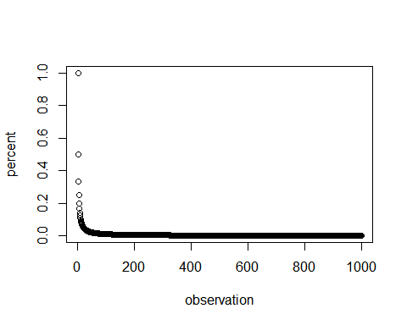

## [1] 0.9234363

## [1] 5.794172

REMEMBER: You can use syntax like -0.0708226 (with backticks instead of quotes) to evaluate r code in your text or refer to variables in your main text that you’ve already created in your code. This is helpful if you want to reference a number result without actually typing it in again. Just remember that you have to have your code chunk BEFORE the text where you reference the variable, otherwise RMD will throw an error. For example:

Referring to variable in code: x = -0.9523969

To include math expressions, write them in between dollar signs: $α=4^{n}$.

Another more complex example: N($μ$ = 7, $σ$ = 2.3)

## References

## Appendix

knitr::opts_chunk$set(echo=F, eval=T)  
  
# create function  
h2o <- function(riv, obs) {  
 set.seed(1001)  
 df <- as.data.frame(matrix(rnorm(riv * obs, mean = 4, sd = 1.4), ncol = obs))  
 paste(rep("Riv", nrow(df)), c(1:nrow(df)), sep = "")  
 rownames(df) <- paste(rep("Riv", nrow(df)), c(1:nrow(df)), sep = "")  
 colnames(df) <- paste(rep("Obs", ncol(df)), c(1:ncol(df)), sep = "")  
   
 df$Test <- rowSums(ifelse(df > 6, 1, 0)) #impair judgment  
 impaired <- length(df$Test[df$Test > 0.1 * obs])  
 percent_impaired <- impaired / riv #calculate percentage of impaired rivers  
 return (percent_impaired) # return the percentage of impaired rivers  
}  
# simulate certain samples using the function above  
a = c(10L, h2o (10, 10))  
print (a)  
h2o (50, 50)  
h2o (100, 100)  
h2o (500, 500)  
percent = h2o (1:1000, 1:1000)  
observation = c(1:1000)  
plot (observation, percent)  
# theoretical values  
pnorm (6, 4, 1.4)  
qnorm (.9, 4, 1.4)  
 x=rnorm(1)